# Solution:

namespace ConsoleApp46

{

nternal class flrogram

{

stat c vo d Ma n(str ng[] args)

{

nt[,] m1 = new nt[3, 3];

Console.Wr teL ne("Enter the elements of Matr x 1:"); for ( nt = 0; < 3; ++)

{

for ( nt j = 0; j < 3; j++)

{

Console.Wr te($"Element [{ }.{j}] = "); m1[ , j] = nt.flarse(Console.ReadL ne());

}

}

Console.Wr teL ne();

Console.Wr teL ne("\t : MATRIX 1 :"); for ( nt = 0; < 3; ++)

{

for ( nt j = 0; j < 3; j++)

{

Console.Wr te("\t{0} ", m1[ , j]);

}

Console.Wr teL ne();

}

Console.Wr teL ne("\nEnter the elements of Matr x 2:"); nt[,] m2 = new nt[3, 3];

for ( nt = 0; < 3; ++)

{

for ( nt j = 0; j < 3; j++)

{

Console.Wr te($"Element [{ }.{j}] = "); m2[ , j] = nt.flarse(Console.ReadL ne());

}

}

Console.Wr teL ne();

Console.Wr teL ne("\t : MATRIX 2 :"); for ( nt = 0; < 3; ++)

{

for ( nt j = 0; j < 3; j++)

{

Console.Wr te("\t{0}", m2[ , j]);

}

Console.Wr teL ne();

}

Console.Wr teL ne("\nAdd t on of Matr x 1 and Matr x 2:\n"); for ( nt = 0; < 3; ++)

{

for ( nt j = 0; j < 3; j++)

{

Console.Wr te("\t{0}", m1[ , j] + m2[ , j]);

}

Console.Wr teL ne();

}

}

}

}

# Output:

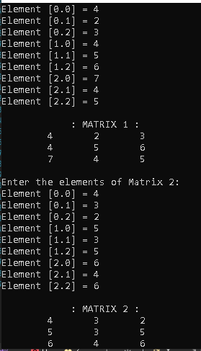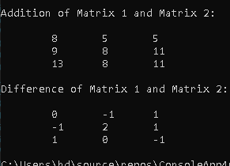

1. **Take N number of user data input and make sure N is greater than 10, which contain name of the user, his/her nationality and his/her eye color. You have to show the max**

**Solution:** stat c vo d Ma n(str ng[] args)

{

nt pkblack = 0, pkbrown = 0, pkgreen = 0, nblack = 0, nbrown = 0,

ngreen = 0, bdblack = 0, bdbrown = 0, bdgreen = 0; Console.Wr te("Enter the number of data: ");

nt n = nt.flarse(Console.ReadL ne()); f (n > 10)

{

str ng[,] prof le = new str ng[n + 1, 3]; prof le[0, 0] = "NAME";

prof le[0, 1] = "NATIONALITY"; prof le[0, 2] = "EYE COLOR";

for ( nt = 1; < n + 1; ++)

{

for ( nt j = 0; j < 3; j++)

{

bangladesh) : ");

}

f (j == 0)

{

Console.Wr te("Enter your name: "); prof le[ , j] = Console.ReadL ne();

}

f (j == 1)

{

Console.Wr te("Enter your nat onal ty (pak stan/ nd a/

prof le[ , j] = Console.ReadL ne();

}

f (j == 2)

{

Console.Wr te("Enter you eye color : "); prof le[ , j] = Console.ReadL ne();

}

Console.Wr teL ne();

}

for ( nt = 1; < n + 1; ++)

{

f (prof le[ , 1] == "pak stan" && prof le[ , 2] == "black")

{

pkblack++;

}

f (prof le[ , 1] == "pak stan" && prof le[ , 2] == "brown")

{

pkbrown++;

}

f (prof le[ , 1] == "pak stan" && prof le[ , 2] == "green")

{

pkgreen++;

}

f (prof le[ , 1] == " nd a" && prof le[ , 2] == "black")

{

nblack++;

}

f (prof le[ , 1] == " nd a" && prof le[ , 2] == "brown")

{

nbrown++;

}

f (prof le[ , 1] == " nd a" && prof le[ , 2] == "green")

{

ngreen++;

}

f (prof le[ , 1] == "bangladesh" && prof le[ , 2] == "black")

{

bdblack++;

}

f (prof le[ , 1] == "bangladesh" && prof le[ , 2] == "brown")

{

bdbrown++;

}

f (prof le[ , 1] == "bangladesh" && prof le[ , 2] == "green")

{

bdgreen++;

}

}

Console.Clear();

f (pkblack > pkbrown && pkblack > pkgreen)

{

Console.Wr teL ne("\t\tflAKISTAN\n\tMax eye color:

Black\n\tNumber of people hav ng black eyes: {0}\n", pkblack);

}

else f (pkbrown > pkblack && pkbrown > pkgreen)

{

Console.Wr teL ne("\t\tflAKISTAN\n\tMax eye color: Brown\n\tNumber of people hav ng brown eyes: {0}\n", pkbrown);

}

else

{

Console.Wr teL ne("\t\tflAKISTAN\n\tMax eye color: Green\n\tNumber of people hav ng green eyes: {0}\n", pkgreen);

}

f ( nblack > nbrown && nblack > ngreen)

{

Console.Wr teL ne("\t\tINDIA\n\tMax eye color: Black\n\tNumber

of people hav ng black eyes: {0}\n", nblack);

}

else f ( nbrown > nblack && nbrown > ngreen)

{

Console.Wr teL ne("\t\tINDIA\n\tMax eye color: Brown\n\tNumber of people hav ng brown eyes: {0}\n", nbrown);

}

else

{

Console.Wr teL ne("\t\tINDIA\n\tMax eye color: Green\n\tNumber of people hav ng green eyes: {0}\n", nblack);

}

f (bdblack > bdbrown && bdblack > bdgreen)

{

Console.Wr teL ne("\t\tBANGLADESH\n\tMax eye color:

Black\n\tNumber of people hav ng black eyes: {0}\n", bdblack);

}

else f (bdbrown > bdblack && bdbrown > bdgreen)

{

Console.Wr teL ne("\t\tBANGLADESH\n\tMax eye color: Brown\n\tNumber of people hav ng brown eyes: {0}\n", bdbrown);

}

else

{

Console.Wr teL ne("\t\tBANGLADESH\n\tMax mum eye color: Green\n\tNumber of people hav ng t: {0}", bdblack);

}

for ( nt = 0; < n + 1; ++)

{

for ( nt j = 0; j < 3; j++)

{

Console.Wr te("{0,20}", prof le[ , j]);

}

Console.Wr teL ne("\n");

}

}

else Console.Wr teL ne("Enter More Than 10 NUmbers of data");

}

}

# Output :

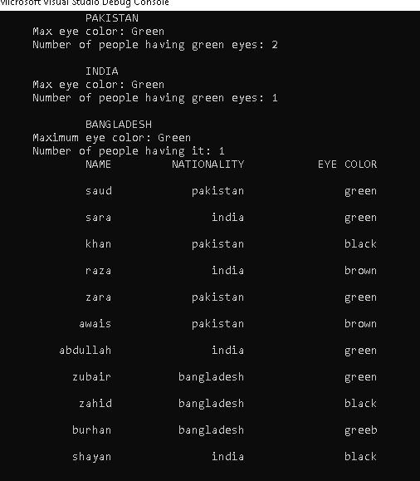

1. **Make a program in C# in which take no. of items, price of items, quantity of items and name of items as input from the user and give the discount according to the following conditions (Use 2D Array):**

# a.If from rice give discount of 30%. b.Else if the total amount is greater than 50,000 and less than 100,000 give discount of 20%. c. Else if the total amount is greater than 100,000 give discount of 30%.

**Solution:**

namespace ConsoleApp47

{

nternal class flrogram

{

stat c vo d Ma n(str ng[] args)

{

Console.Wr te("How Much Item U want to Buy : "); nt t = Convert.ToInt32(Console.ReadL ne());

str ng[,] tems = new str ng[ t, 4]; for ( nt = 0; < t; ++)

{

for ( nt j = 0; j < 4; j++)

{

f (j == 0)

{

Console.Wr te(" Enter the name of the Item: "); tems[ , j] = Console.ReadL ne();

", tems[ ,j]);

}

f (j == 1)

{

Console.Wr te(" Enter the pr ce of the Item: "); tems[ , j] = Console.ReadL ne();

}

f (j == 2)

{

Console.Wr te(" Enter the quant ty of tem {0}:

tems[ , j] = Console.ReadL ne();

}

f (j == 3)

{

tems[ , j] = ((Convert.ToInt32( tems[ , 1])) *

(Convert.ToInt32( tems[ , 2]))).ToStr ng();

}

}

}

double t = 0; Console.Clear();

for ( nt = 0; < t; ++)

{

for ( nt j = 0; j < 4; j++)

{

Console.Wr te("{0}\t ", tems[ , j]);

}

Console.Wr teL ne();

}

for ( nt = 0; < t; ++)

{

for ( nt j = 0; j < 4; j++)

{

f (j == 3)

{

t += Convert.ToInt32( tems[ , j]);

}

}

}

No)");

p,dsc);

double dsc = 0, p = 0;

Console.Wr teL ne("Are You From Bahr a Un vers tyo (Y for Yes , N for

str ng b = Console.ReadL ne(); f (b == "y" || b == "Y")

{

dsc = 0.3 * t; p = t - dsc;

Console.Wr teL ne(" Total Amount To pay = {0} \t D scount = {1} ",

}

else f (t > 50000 && t <= 100000)

{

p, dsc);

dsc = 0.2 * t; p = t - dsc;

Console.Wr teL ne(" Total Amount To pay = {0} \t D scount = {1} ",

}

else f (t > 100000)

{

p, dsc);

# Output :

}

else

{

}}}}

dsc = 0.3 * t; p = t - dsc;

Console.Wr teL ne(" Total Amount To pay = {0} \t D scount = {1} ",

Console.Wr teL ne("Total Amount To pay = {0} ", p);

